Day 12 - 25th june 2025

Task 1:
What is the binary 8 bit representation of A?
The uppercase letter 'A' has an ASCII (American Standard Code for Information Interchange) value of 65.
The largest power of 2 less than or equal to 65 is 2^6=64. So, the 7th bit (from the right, starting at 0) is 1.
65−64=1. The largest power of 2 less than or equal to 1 is 2^0=1. So, the 1st bit (from the right) is 1.
All other bits are 0.
65 / 2 == 1
32 / 2 == 0
16 / 2 == 0
8 / 2 == 0
4 / 2 == 0
2 / 2 == 0
1 / == 1 = ⇒ 1 0 0 0 0 0 1
For an 8-bit representation, we simply pad with a leading zero:
01000001
Task 2:
What is the binary value of a?

To represent 97 in 8-bit binary, we convert it as follows:
- The largest power of 2 less than or equal to 97 is 2^6=64. So, the 7th bit (from the right, starting at 0) is 1.
- 97−64=33. The largest power of 2 less than or equal to 33 is 2^5=32. So, the 6th bit is 1.
- 33−32=1. The largest power of 2 less than or equal to 1 is 2^0=1. So, the 1st bit is 1.
- All other bits are 0.
So, the 7-bit binary representation of 97 is 1100001.

Task 3:

Types of Computer memory with examples.. Explain ..

1. Primary Memory (Main Memory):
This is the computer's immediate workspace, directly accessible by the CPU. It's very fast but typically volatile, meaning data is lost when the power turns off. Think of it as your desk where you keep active files.
- Example: RAM (Random Access Memory), like the DDR4 sticks in your PC.
2. Secondary Memory (Storage):
Used for long-term storage of data and programs. It's non-volatile, so data persists even without power, and offers much larger capacity at a lower cost than primary memory. It's slower, so data must first move to primary memory for the CPU to use it.
- Example: USB Flash Drives / Memory Cards, Solid State Drives (SSDs), Optical Discs (CDs, DVDs, and Blu-ray discs)

Task 4:

What do you understand by data structures..?
Data structure is a specialized format for organizing, processing, retrieving, and storing data. The choice of a data structure is crucial because it directly impacts the efficiency (in terms of time and space) of the algorithms that operate on that data. Different data structures are optimized for different types of operations.

Task 5:

What are the operations on data structures ?
Operations on data structures refer to the various actions that can be performed on the data elements organized within that structure. These operations define how we interact with and manipulate the stored data. While specific data structures might have unique operations (like "push" and "pop" for a stack), there are several fundamental operations common across many of them.
- Insertion: Adding a new element.
- Deletion: Removing an existing element.
- Searching: Finding a specific element.
- Traversal: Visiting every element.
- Access: Retrieving an element's value.
- Sorting: Arranging elements in a specific order.
- Merging: Combining two data structures.
- Updating: Modifying an element's value.

Task 6:

What are static and dynamic arrays key points summarize in a table

Feature | Static Arrays | Dynamic Arrays
Size | Fixed at compile time or initialization. | Can change (grow or shrink) at runtime.
Memory Alloc. | Compile-time (stack or static/global segment). | Runtime (heap), using pointers.
Memory Use | Fixed, can lead to wasted space or overflow. | Flexible, efficient memory use for varying data.
Resizing | Not possible directly; must create a new one. | Automatic resizing (often by reallocating and copying).
Performance | Faster direct access; no resizing overhead. | Slower inserts/deletes if resizing is needed.
Complexity | Simpler to implement. | More complex implementation (manual memory management or library support).
Common Use | Fixed-size data, embedded systems, raw performance needs. | Flexible data collections, standard library lists (e.g., Python lists, C++ std::vector).
Example Code | int arr[10]; (C/C++) | std::vector<int> vec; (C++), ArrayList (Java), list (Python)

Task 7:

Reverse an array. write a code.

import java.util.Arrays;

public class Task007 {

public static void reverse(int[] arr) {
int start = 0;
int end = arr.length - 1;
int temp;

while (start < end) {
// Swap elements at start and end
temp = arr[start];
arr[start] = arr[end];
arr[end] = temp;

start++;
end--;
}
}

public static void main(String[] args) {
// Original array
int[] arr = {1, 2, 3, 4, 5};

// Print original array
System.out.println("Original Array: " + Arrays.toString(arr));

// Reverse the array
reverse(arr);

// Print reversed array
System.out.println("Reversed Array: " + Arrays.toString(arr));
}
}

Task 8:

Reverse a string .. write a code.

Hint: take a name from the user and display the name in reverse order..
import java.util.Scanner;

public class Task008 {

public static void main(String[] args) {
// Create Scanner object for user input
Scanner scanner = new Scanner(System.in);

// Prompt user for input
System.out.print("Enter your name: ");
String name = scanner.nextLine();

// Reverse the string
String reversed = "";
for (int i = name.length() - 1; i >= 0; i--) {
reversed += name.charAt(i);
}

// Display reversed string
System.out.println("Reversed name: " + reversed);

scanner.close();
}
}

Task 9:

Leetcode and Hackerrank … accounts ..

AlgoMaster.io - Master Software Engineering Interviews

Task 10:

public class Example {
public static void main (String[] args) {
int[] arr1 = {11, 34, 66, 75};
int n1 = arr1.length;
int[] arr2 = {1, 5, 19, 50, 89, 100};
int n2 = arr2.length;
int[] merge = new int[n1 + n2];
int i = 0, j = 0, k = 0, x;
System.out.print("Array 1: ");
for (x = 0; x < n1; x++)
System.out.print(arr1[x] + " ");
System.out.print("\nArray 2: ");
for (x = 0; x < n2; x++)
System.out.print(arr2[x] + " ");
while (i < n1 && j < n2) {
if (arr1[i] < arr2[j])
merge[k++] = arr1[i++];
else
merge[k++] = arr2[j++];
}
while (i < n1)
merge[k++] = arr1[i++];
while (j < n2)
merge[k++] = arr2[j++];
System.out.print("\nArray after merging: ");
for (x = 0; x < n1 + n2; x++)
System.out.print(merge[x] + " ");
}
}

What is the above code snippet doing..?

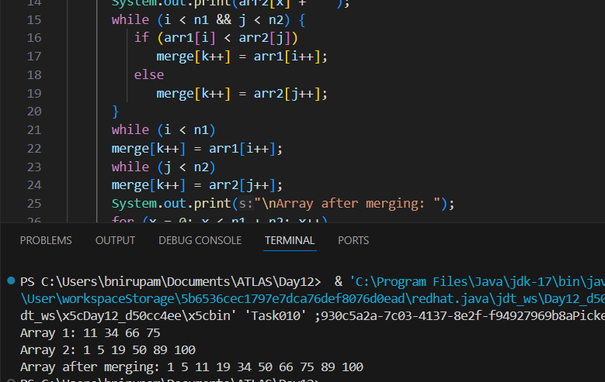

It merges two already sorted arrays into a new sorted array.

Task 11:

What do you know about hash table?

A hash table is a powerful data structure that allows for fast data access using key-value pairs. It is widely used in computer science due to its average constant time complexity for insertion, deletion, and lookup operations.
It works by using a hash function to map keys directly to an index in an internal array. While multiple keys can sometimes "collide" and map to the same index, strategies like chaining or open addressing resolve this.
Task 12:

Wap to create a hash table and display them..

Hint 👍

Import java.util.Hashtable;
Import java.util.Map;

import java.util.Hashtable;
import java.util.Map;

public class Task012_DS_HashTable {
public static void main(String[] args) {
Hashtable<String, Integer> ht = new Hashtable<>();
ht.put("Anitha", 101);
ht.put("Kavitha", 102);
ht.put("Meera", 103);

for (Map.Entry<String, Integer> e : ht.entrySet())
System.out.println(e.getKey() + " " + e.getValue());
}
}

// Map is an interface

// hash table --> slower , sync , thread safe, no null value accepted

// hash map --> faster while retrieving, asynchro , only one null key and multiple null values..
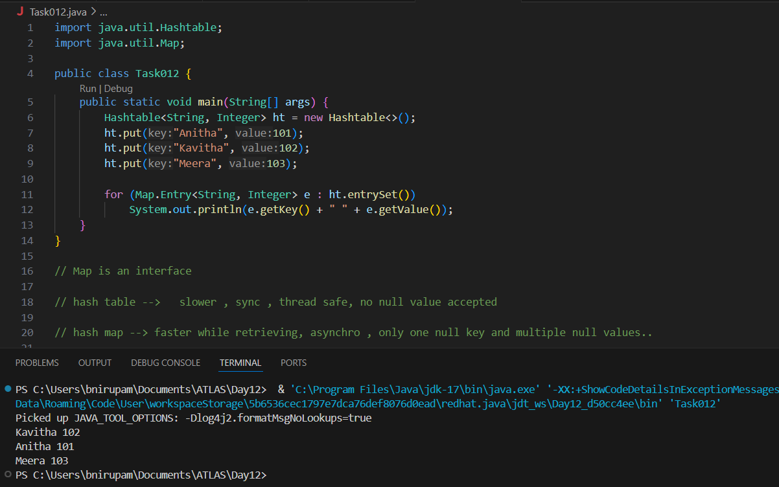

Task 13:
Wap to create a hash map and display them..
import java.util.HashMap;
import java.util.Map;

public class HashMapExample {
public static void main(String[] args) {
// Create a HashMap
HashMap<String, Integer> map = new HashMap<>();

// Add key-value pairs to the HashMap
map.put("Niru", 25);
map.put("Petu", 30);
map.put("Ashu", 28);
map.put("Rishu", 35);

// Display the HashMap
System.out.println("HashMap contents:");

for (Map.Entry<String, Integer> entry : map.entrySet()) {
System.out.println("Name: " + entry.getKey() + ", Age: " + entry.getValue());
}
}
}

Task 14:

Hash table advantages and disadvantages

Advantages:

- Blazing Fast: Offers average O(1) time for adding, deleting, and finding data.

- Scalable: Maintains speed even with huge datasets.

- Flexible Keys: Works with various data types for keys.

- Efficient for Large Datasets:

Disadvantages:

- Worst-Case Slowdown: Can degrade to O(N) performance with many collisions (poor hash function).

- No Order: Data is not stored in a sorted manner, making range queries difficult.

- Memory Overhead: Can sometimes use more memory than needed due to empty slots or collision structures.

- Hash Function Dependent: Performance critically relies on a good hash function to minimize collisions.

Task 15

Linear probing in Hash table

public class HashTable<Key, Value> {
private class HashTableNode {
private Key key;
private Value value;
private boolean active;
private boolean tombstoned; // Allow reuse of removed slots
public HashTableNode() {
// All nodes in array will begin initialized this way
key = null;
value = null;
active = false;
tombstoned = false;
}
public HashTableNode(Key initKey, Value initData) {
key = initKey;
value = initData;
active = true;
tombstoned = false;
}
}

private final static int TABLE_SIZE = 9;
private Object[] table;
public HashTable() {
// Since HashNodeTable has generics, we can not have
// a new HashNodeTable[], so use Object[]
table = new Object[TABLE_SIZE];
for (int j = 0; j < TABLE_SIZE; j++)
table[j] = new HashTableNode();
}
public Value put(Key key, Value value) // TBA

Task 16:

Methods of Hash table plz list them..

- put(K key, V value): Inserts a key-value mapping into the Hashtable. If the key already exists, the old value is replaced with the new one.

- get(Object key): Returns the value associated with the specified key. Returns null if the key is not found.

- remove(Object key): Removes the key-value mapping for the specified key from the Hashtable.

- containsKey(Object key): Returns true if the Hashtable contains a mapping for the specified key, otherwise returns false.

- containsValue(Object value): Returns true if the Hashtable maps one or more keys to the specified value, otherwise returns false.

- isEmpty(): Returns true if the Hashtable contains no key-value mappings, otherwise returns false.

- size(): Returns the number of key-value mappings in the Hashtable.

- clear(): Removes all key-value mappings from the Hashtable.

- keySet(): Returns a Set view of the keys contained in the Hashtable.

- values(): Returns a Collection view of the values contained in the Hashtable.

- entrySet(): Returns a Set view of the key-value mappings contained in the Hashtable.

- rehash(): Increases the size of the Hashtable and rehashes all of its keys. This method is protected and typically handled internally by the Hashtable for performance optimization.
- clone(): Returns a shallow copy of the Hashtable instance.

Task 17:

In Task 13 of hash Map .. we were using string and integer / integer and string
Like HashMap<Integer, String>

Can you change to String and string and see if it works
Like this HashMap<String, String> ? will this work?
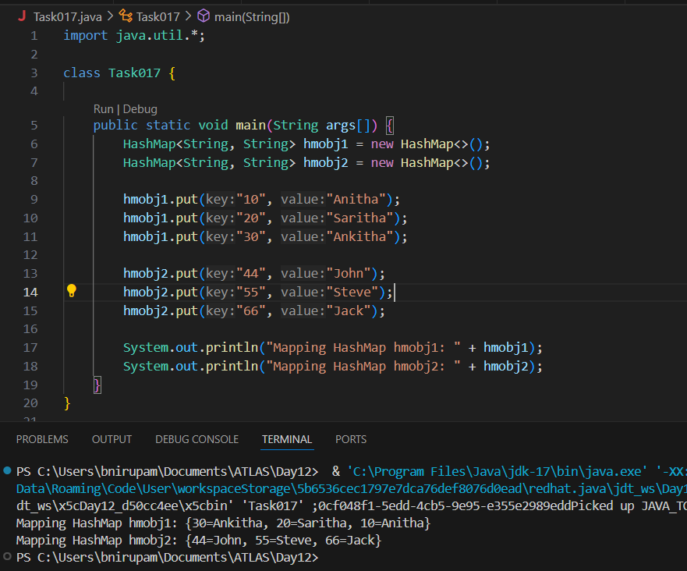

Java's HashMap is fully generic and allows any object types (like String, Integer, Double, etc.) as keys or values.

Task 18:

Explain the internal working of a HashMap. With diagram..
- put(key, value) (Insertion):
- The key is passed to the hash function to compute its hash code.
- The hash code is used to calculate the bucket index in the internal array.
- The HashMap goes to that bucket.
- If the bucket is empty, the new Node (containing the key-value pair) is placed directly there.
- If the bucket is already occupied (a collision), the HashMap traverses the linked list (or tree) at that bucket and adds the new Node to it. If a node with the exact same key already exists, its value is typically updated.
- The HashMap might also resize its internal array (and rehash all elements) if the number of entries exceeds a certain "load factor" threshold, to maintain efficiency.
- get(key) (Retrieval):
- The key is passed to the hash function to compute its hash code.
- The hash code is used to calculate the bucket index.
- The HashMap goes directly to that bucket.
- It then traverses the linked list (or tree) at that bucket. For each Node in the list, it compares the key of the node with the key being searched for (using both hash code and equals() method for true equality).
- If a matching key is found, its associated value is returned. If the end of the list is reached without finding the key, it means the key is not present.

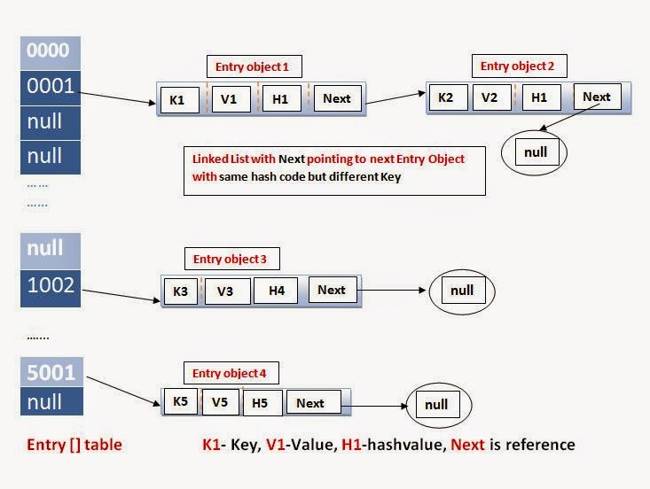

Task 19:

Try to add 1 null value in the key and run the hash map code..

Also add one more null value to the key and see the result.. import java.util.HashMap;

public class Task019 {
public static void main(String[] args) {
HashMap<String, String> map = new HashMap<>();

map.put(null, "First Null");
map.put("101", "Niru");
map.put("102", "Mom");

System.out.println("After first null key insertion: " + map);

// Adding another null key with a different value
map.put(null, "Second Null");

System.out.println("After second null key insertion (overwrite): " + map);
}
}

Task 20:

How many methods are there to create a hash Map?
Different methods to create a hashmap in java :

1) Constructing a hashmap with default capacity
ex: HashMap<String, Integer> hm1 = new HashMap<String, Integer>();

2) Constructing a hashmap with a capacity 10
ex: HashMap<String, Integer> hm2 = new HashMap<String, Integer>(10);

3)copy one map to another map
ex: HashMap<String, Integer> hm3 = new HashMap<String, Integer>( hm2);

4) Specifying load factor along with the capacity

ex:
HashMap<String, Integer> hm4= new HashMap<String, Integer>(10, 0.75f);

Initial capacity ===10
Load factor === 0.75f

Task 21:

Wap to make a Hashmap synchronized..

Plz note : Hash Map are - asynchronous in nature..

import java.util.Collections;
import java.util.HashMap;
import java.util.Map;

public class task021_DS_HashMap_SyncMap {
public static void main(String[] args) {
HashMap<String, Integer> Hm1 = new HashMap<String, Integer>();
Map<String, Integer> syncMap = Collections.synchronizedMap(Hm1);
}
}

Do hash tables have linked lists internally? Yes, commonly! Many hash table implementations, especially those using the separate chaining method for collision resolution, use linked lists (or sometimes balanced trees like Red-Black Trees in newer Java versions) at each array "bucket." When multiple keys hash to the same index, their key-value pairs are stored in a linked list at that bucket.
Do collisions occur in hash maps? What are they?
Yes, collisions are inevitable in hash maps. A collision occurs when two different keys, when processed by the hash function, produce the same hash code or map to the same index in the internal array. This happens because the range of possible keys is often much larger than the number of available buckets in the array.
What is load factor and how the capacity increases?
The load factor is a measure of how "full" a hash table is. It's calculated as:
Load Factor=Total number of buckets (capacity)Number of elements​
When the load factor exceeds a predefined threshold (e.g., 0.7 or 0.75 in many implementations), the hash table's capacity increases through a process called rehashing. This involves:
- Creating a new, larger internal array (often double the size).
- Re-calculating the hash code and new bucket index for all existing key-value pairs.
- Moving all existing key-value pairs from the old array to their new positions in the larger, new array. This process is computationally expensive but helps maintain efficient average-case performance by reducing collision probability.

